Лекция 12а

ПСКП, ПОИТ-3

**Node.js: Mongoose**

1. **Mongoose:** ODM-библиотека (Object Document Mapping) для работы с MongoDB.

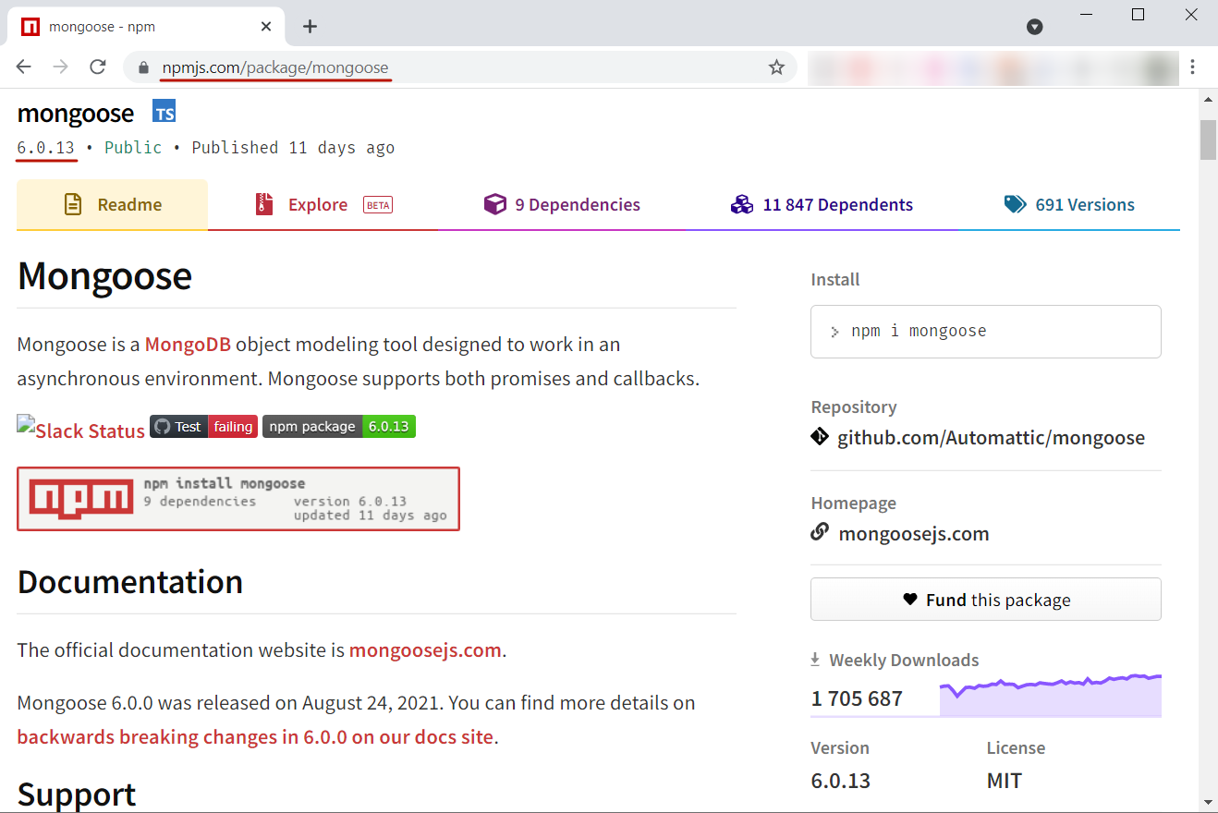

1. **Mongoose:** <https://mongoosejs.com/docs/index.html>
2. **Mongoose:** <https://metanit.com/web/nodejs/6.6.php>
3. **Mongoose:** npm install mongoose
4. **Mongoose:** scheme, model, connect

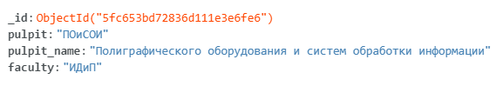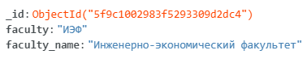

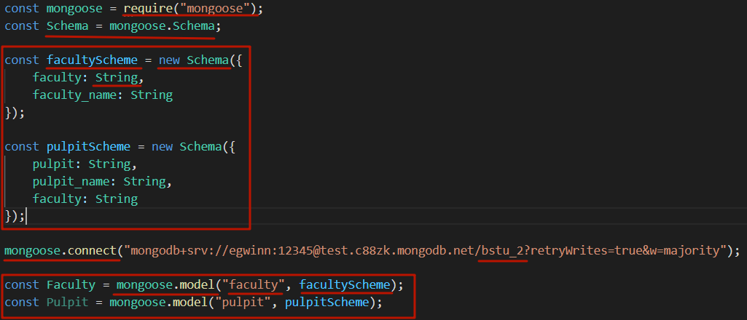

1. **Mongoose:** client, connect, поиск, find, findOne, findById

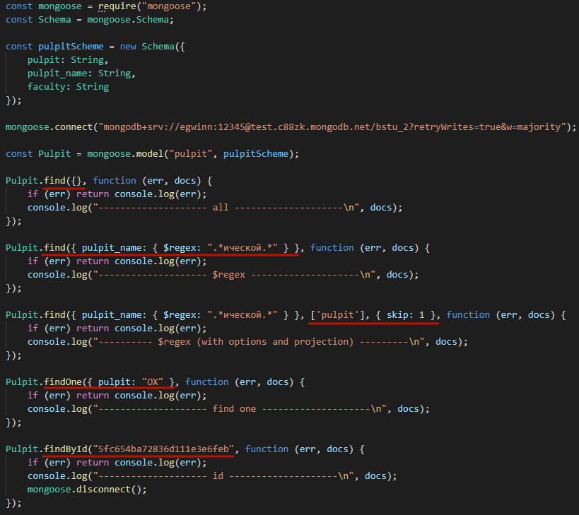

|  |  |
| --- | --- |
|  |  |
|  |
|  |  |

1. **Mongoose:** client, connect, поиск, find, exec

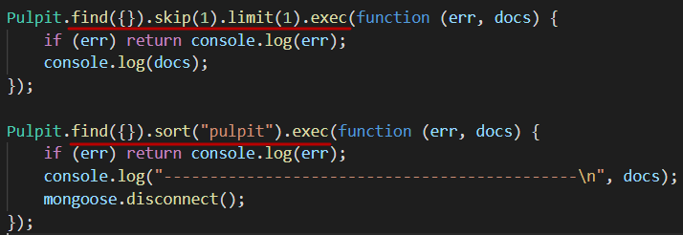

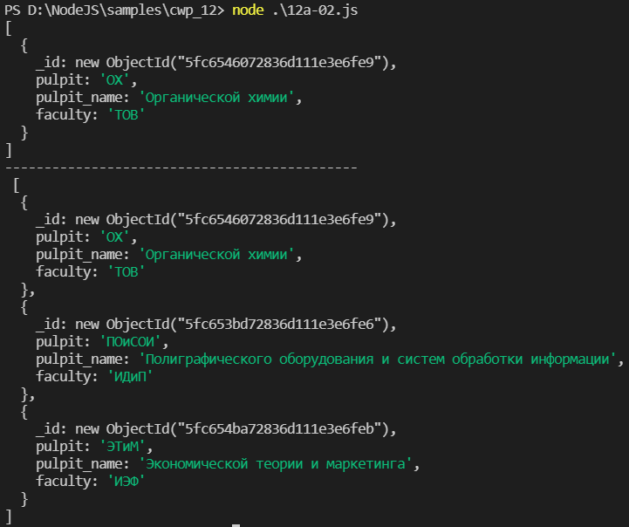

1. **Mongoose:** создание документа,save

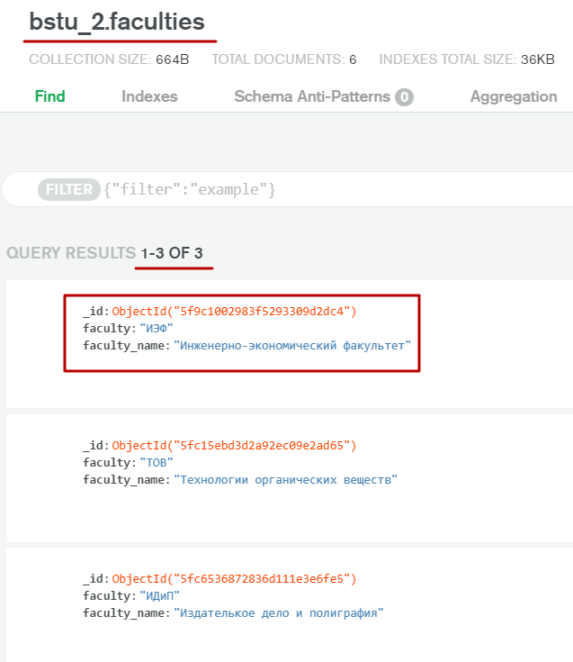

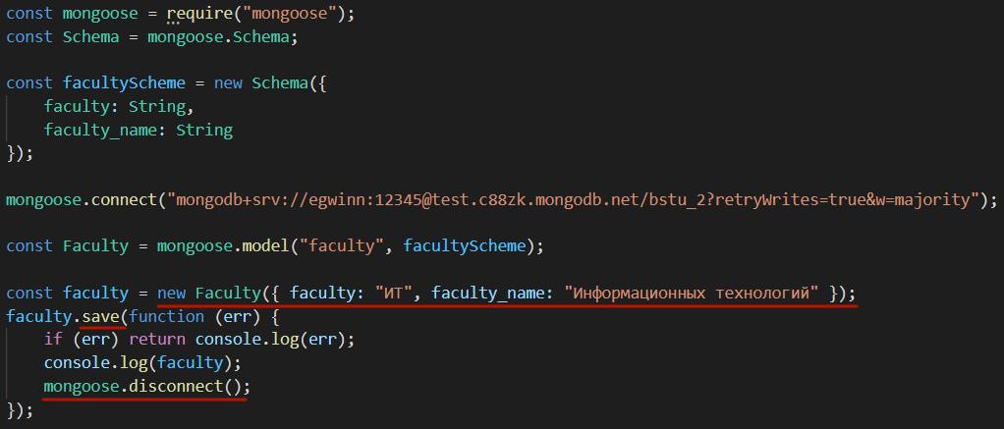

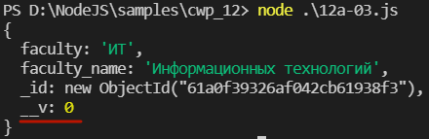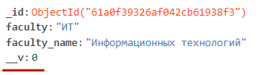

1. **Mongoose:** создание документа,create

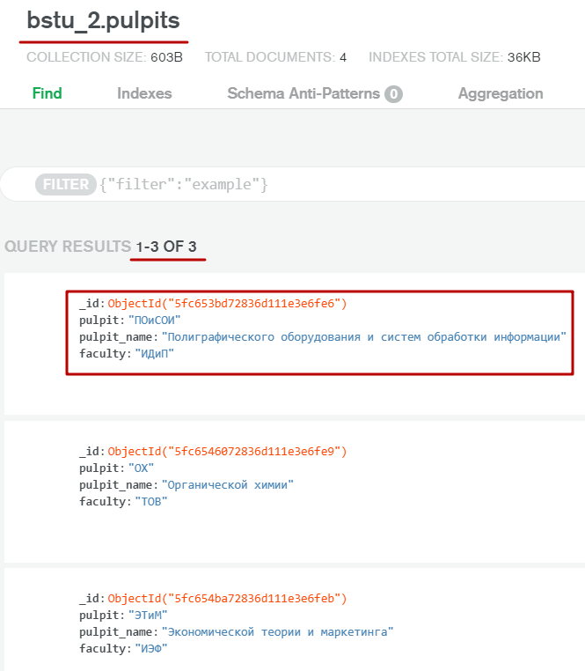

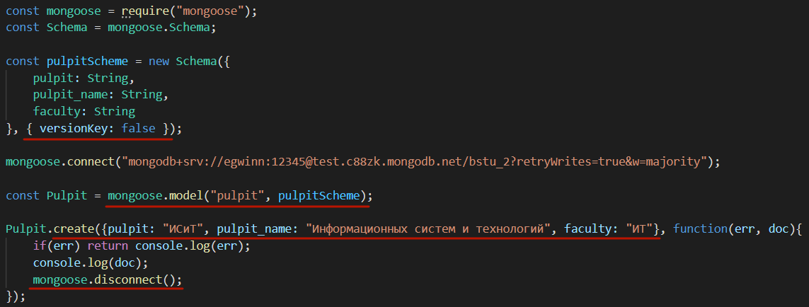

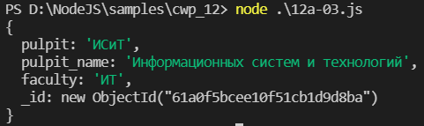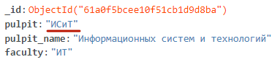

1. **Mongoose:** удаление документа(ов), deleteOne / deleteMany / findByIdAndDelete / findOneAndDelete

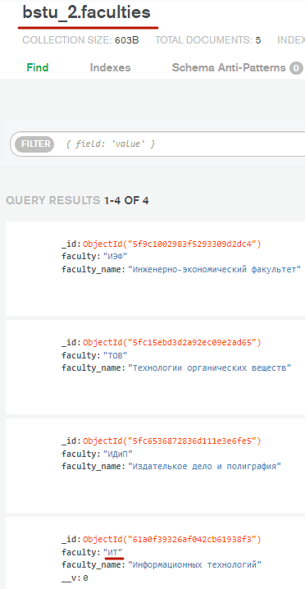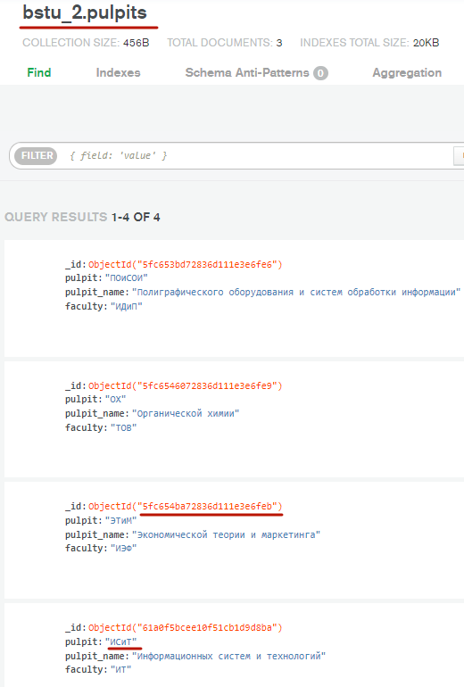

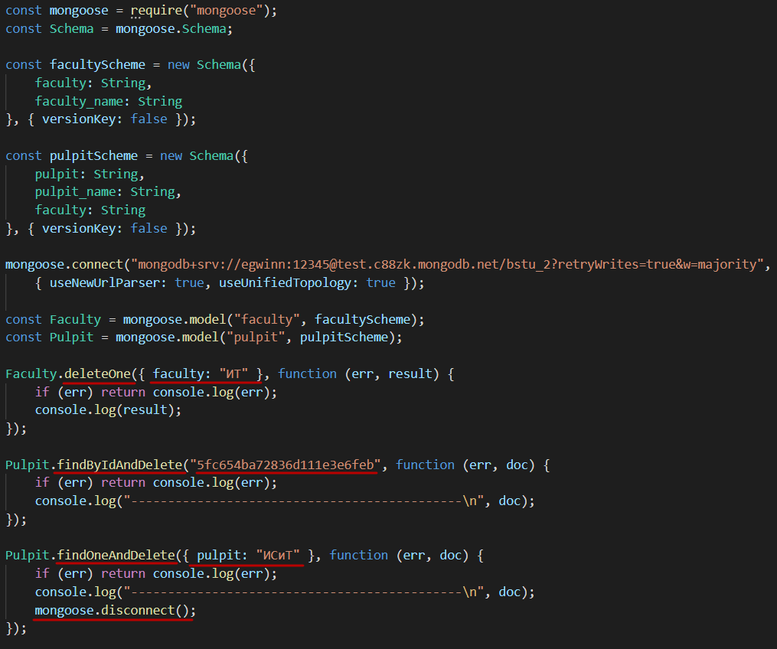

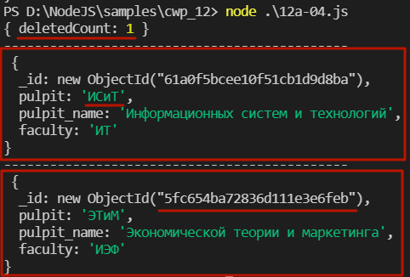

1. **Mongoose:** обновление документа,updateOne / updateMany findByIdAndUpdate / findOneAndUpdate

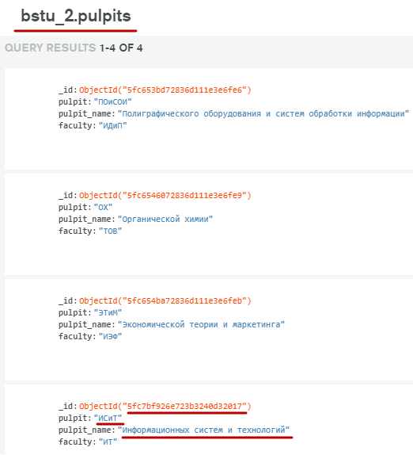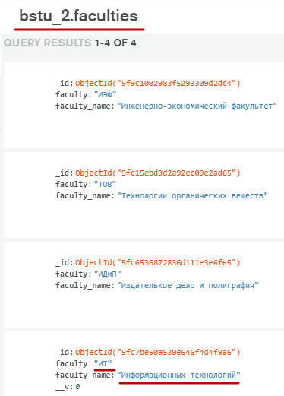

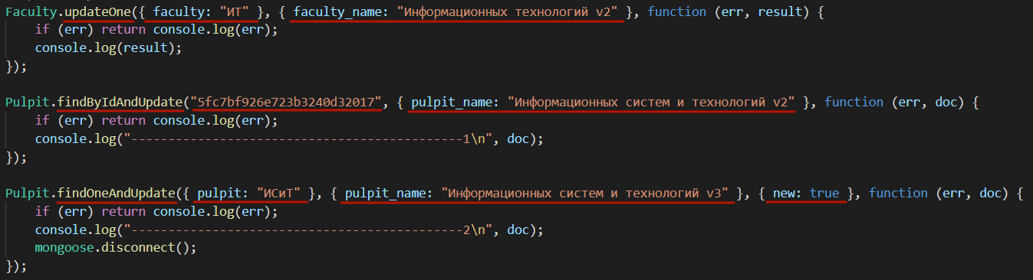

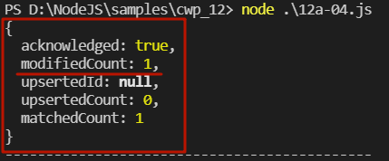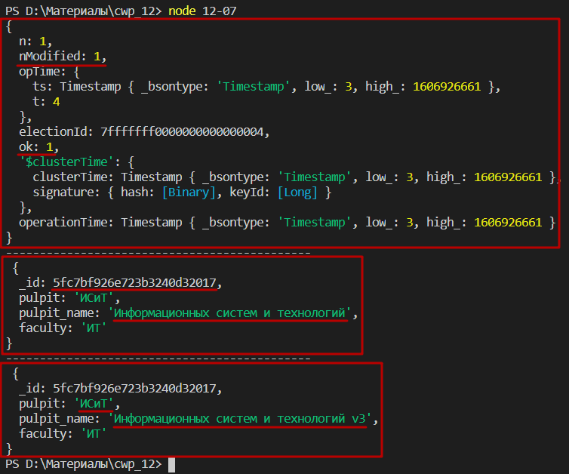

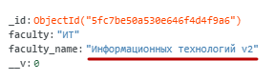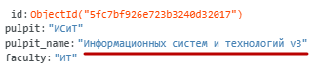

1. **Mongoose:** scheme, ограничения, валидация

<https://mongoosejs.com/docs/schematypes.html>

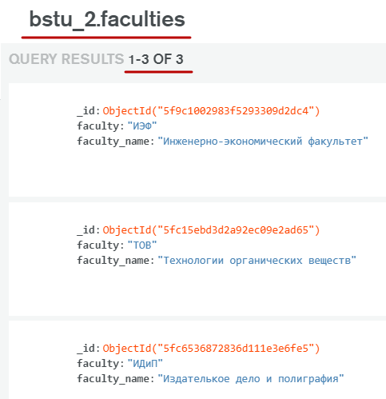

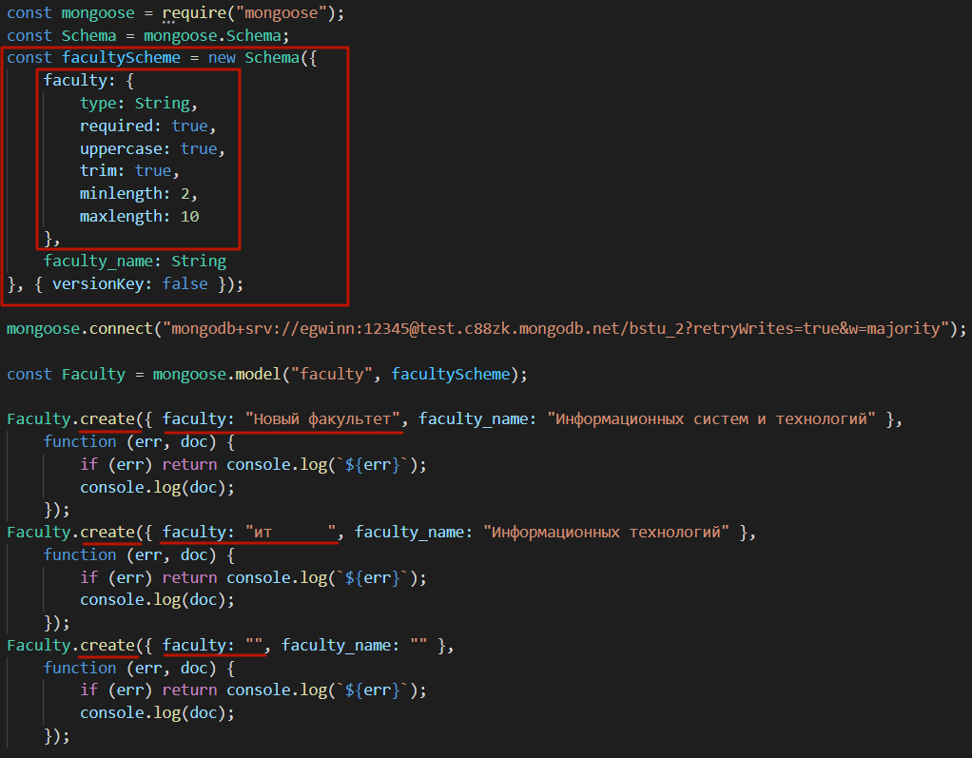

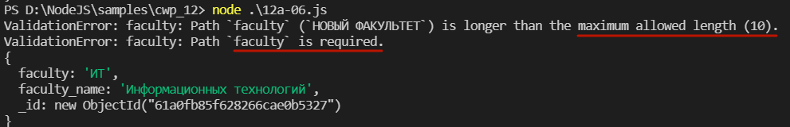

1. **Mongoose:** session, transaction, commit

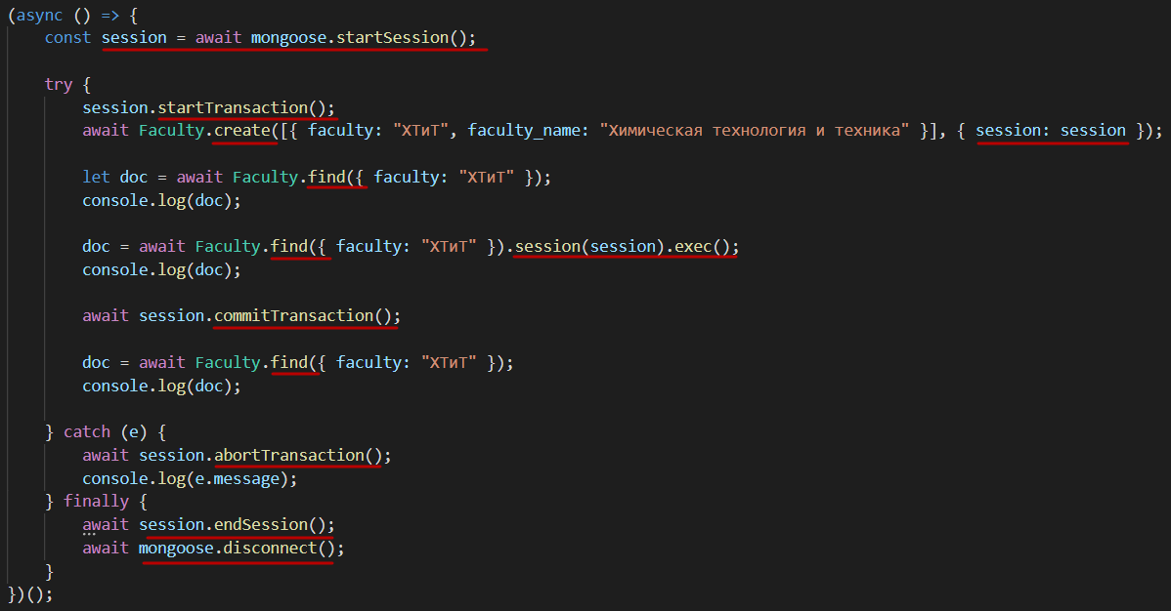

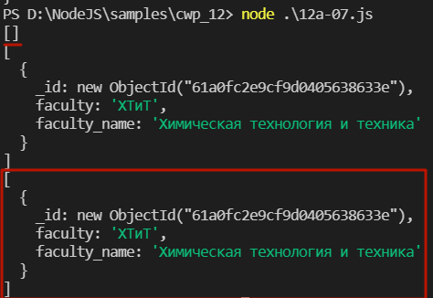

1. **Mongoose:** session, transaction, abort

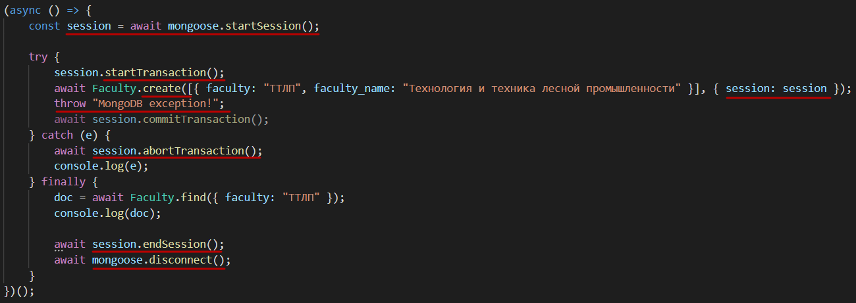

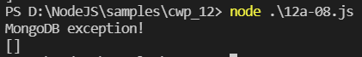

1. **Mongoose:** session, withTransaction, auto commit/abort

